**PACKAGE DIAGRAM**

**AIM:**

To design a package diagram for the Online Exam Registration System.

**DEFINITION:**

Package diagram is UML structure diagram which shows packages and dependencies between the packages. Model diagrams allow to show different views of a system, for example, as multi-layered (aka multi-tiered) application - multi-layered application model.

**PACKAGE DIAGRAM:**

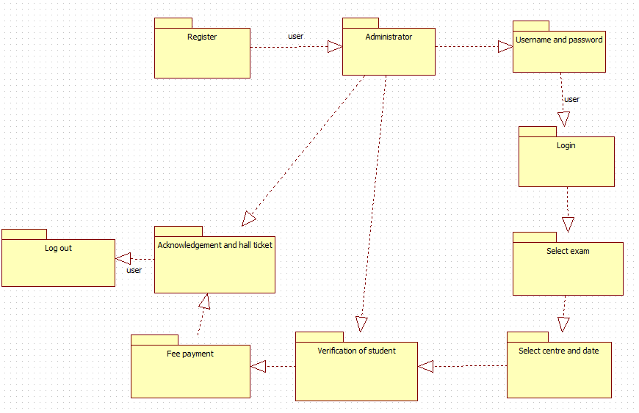

**RESULT:**

Thus a package diagram has been designed for Exam Registration System.